**Technical Documentation – PENC MiddleWare – WCC Refresh Cleanup**

1. Workflow **PENC Middleware - WCC Refresh Cleanup** – Cleans up WCC Environments WCCD, WCCT and WCCM during refreshes. This replaces the manual WCC Archiver process. The current WCC Archiver process purges based on the following custom queries, provided by the Release Management team:

xSourceEnvironment like ‘ENVIRONMENT' AND  
dDocAuthor = 'UCMBATCH' AND  
dInDate < CurrentTimeStamp  
  
xSourceEnvironment like 'ENVIRONMENT' AND  
dDocAuthor = 'ucmbatch' AND  
dInDate < CurrentTimeStamp  
  
xSourceEnvironment like 'ENVIRONMENT' AND  
xCorrespondenceType = 'LETTR' AND  
dInDate < CurrentTimeStamp  
  
xSourceEnvironment like 'ENVIRONMENT' AND  
xCorrespondenceType = 'STMNT' AND  
dInDate < CurrentTimeStamp  
  
xSourceEnvironment like 'ENVIRONMENT' AND  
xCorrespondenceType = 'TAXSL'  AND  
dInDate < CurrentTimeStamp

The Ansible Tower workflow creates WCC hda files based on the following query using the Oracle Schema UCMREAD. The Ansible Tower user provides the WCC Environment to clean up (i.e. DEV3, RDEV, DEVL, TST1,…), the UCMREAD Schema password and how many days to keep (if any):

SELECT '@Properties LocalData'|| chr(10)

|| 'IdcService=DELETE_DOC' || chr(10)

|| 'dID=' || Revisions.DID || chr(10)

|| 'dDocName='||Revisions.DDOCNAME || chr(10)

|| '@end' || chr(10)

|| '<<EOD>>' || chr(10)

FROM

wcc_ocs.Revisions,

wcc_ocs.DocMeta,

wcc_ocs.Documents,

wcc_ocs.RevClasses

WHERE Revisions.dID=DocMeta.dID

AND Revisions.dID=Documents.dID

AND Revisions.dDocName = RevClasses.dDocName

AND dIsPrimary = 1

AND dInDate < sysdate - **{{wcc_days_to_keep}}**

AND (upper(ddocauthor) = 'UCMBATCH'

OR upper(xCorrespondenceType) = 'TAXSL'

OR upper(xCorrespondenceType) = 'STMNT'

OR upper(xCorrespondenceType) = 'LETTR')

AND xsourceenvironment = **{{wcc_env}}**

The hda file created has the following format:

@Properties LocalData

IdcService=DELETE_DOC

dID=1008180

dDocName=MFC997.PDF

@end

<<EOD>>

@Properties LocalData

IdcService=DELETE_DOC

dID=1005783

dDocName=MINIMAL2.PDF

@end

<<EOD>>

@Properties LocalData

IdcService=DELETE_DOC

dID=1006802

dDocName=MFC11.PDF

@end

It then sends a summary report of the number of documents that will be purged to the Ansible Tower User who initiated the workflow. The Ansible Tower User then needs to approve the purge.

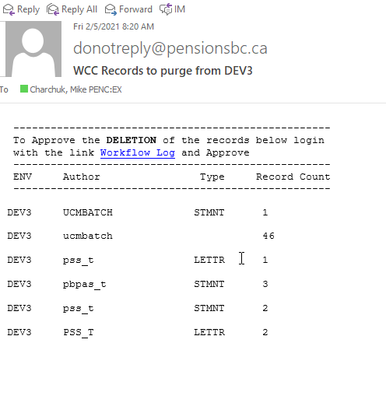

Once approved the workflow splits the hda file into smaller chucks of 10,000 documents or less (based on information provided by Doug Muir), adds the following header:

<?hda version="5.1.1 (build011203)" jcharset=Cp1252 encoding=iso-8859-1?>

and executes the IdcCommand against each of the files to purge the WCC Documents.

1. Worflow Specification



1. Survey – User Supplied Variables

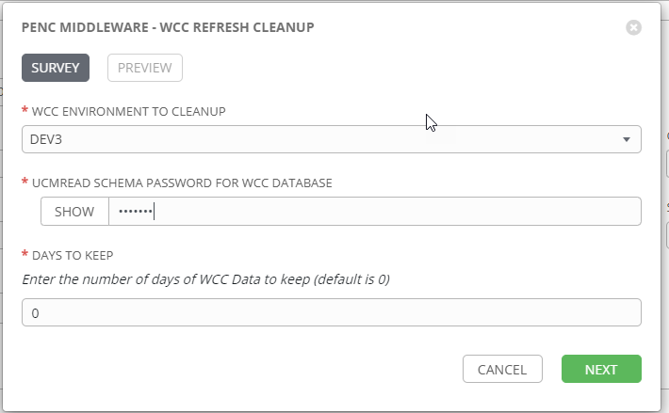

| **Survey Extra Variables** | **Prompt** | **Type** | **Description and Usage** |
| --- | --- | --- | --- |
| wcc_env | WCC Environment To Cleanup | Multiple Choice Single Pick | Drop down list of the WCC SOURCE Environment to cleanup.  Current List:  DEV3  DEVL  RDEV  TST1  TST2  TST3  MUAT |
| SchemaPassword | UCMREAD Schema Password for WCC Database | Password | The oracle UCMREAD Schema Password |
| wcc_days_to_keep | Days To Keep  Enter the number of days of WCC Data to keep (default is 0) | Text (1024) | The number of days of WCC Data for the Source Environment to keep. The default is 0 and should normally not be changed. If the Developers or Testers have populated some test data in the last few days that they need kept this can be modified. |

1. Jobs Used by the workflow - http://owl.penc.local:18080/svn/deploy_automation/trunk/Ansible_PlayBooks/Utilities

| **Job Template** | **Ansible Playbook** | **Credentials / host** | **Project** | **Description and Usage** |
| --- | --- | --- | --- | --- |
| create_wcc_cleanup_vars_ansible | create_wcc_cleanup_vars_ansible.yml | None – runs on localhost as awx linux user | Utilities | Creates Variables/Artifacts for use within the workflows, based on the User supplied survey results.  Artifacts Defined with examples  Working_Directory: /pencmw_common/WCC/CleanUp/DEV3/20210205_0819  date_time: '20210205_0819'  tower_hostname: pdeploy1bcp.penc.local  wcc_host: deiphontes1bcp  wcc_schema: ucmread  wcc_sid: wccd |
| wcc_create_doc_ids_to_purge | wcc_create_doc_ids_to_purge.yml | Oracle on {{wcc_host}} | Utilities | Creates {{Working_Directory}} to house working files.  Creates sql files:  {{Working_Directory}}/WCC_DOC_ID_EXTRACT_QUERY.sql – which will create the hda file.  {{Working_Directory}}/ WCC_DOC_ID_REPORT_QUERY.sql – which is will create the summary report to the Ansible Tower user.  Executes:  {{Working_Directory}}/WCC_DOC_ID_EXTRACT_QUERY.sql to create the hda file ‘purge_ids_for_{{wcc_env}}.txt.  {{Working_Directory}}/ WCC_DOC_ID_REPORT_QUERY.sql to create purge_ids_report.txt to send to the Ansible Tower user.  Emails the purge_ids_report.txt to the Ansible Tower user. |
| Continue Purging WCC Documents | None – Approval Step | NA | NA | This gives the Ansible User a chance to review the summary report prior to moving ahead with the cleanup. |
| wcc_purge_doc_ids | wcc_purge_doc_ids.yml | Oracle on {{wcc_host}} | Utilities | Splits the purge_ids_for_{{wcc_env}}.txt into smaller chunks (< 10,000 records), files created are prefixed with {{wcc_env}}_ and given an extension of .hda.  Inserts the ‘<?hda version=\"5.1.1 (build011203)\" jcharset=Cp1252 encoding=iso-8859-1?>’ header into each of the {{wcc_env}}_###.hda files.  Executes:  IdcCommand –f {{item}} –u sysadmin –c auto with {{item}} being populated with {{Working_Directory}}/{{wcc_env}}_*.hda |
| wcc_clean_up_temp_files |  | None – runs on localhost as awx linux user | Utilities | Removes the {{Working_Directory}}/purge_ids_for_{{wcc_env}}.txt file which is owned by the awx user.  Removes the {{Working_Directory}}/purge_ids_report.txt file which is owned by the awx user.  This allows the Oracle id on the {{wcc_host}} server the ability to clean up the {{Working_Directory}} without interference from files owned by awx. |